

IXLA Device SW Integration
Reference Manual

Last revision: 12/06/2025

Index
1. Introduction 3
2. AIDA Server 4
3. AIDA WebApp 5
4. Internal Database 6
5. Layouts Files (SJF) 7
6. Job Template 8
7. Webhooks Receiver 9
8. Webhook Targets 10
9. SKD Client 12
10. Integration Process 13
11. Demo app 14
11.1 Main Form 14
11.2 InsertDataForm 15
11.3 JobStatusForm 16
11.4 Source Code 16
11.4.1 MachineInterface 17
11.4.2 NotificationsController 17
12. C# sample code 18
12.1 Connect 19
12.2 Start scheduler 20
12.3 Stop scheduler 22
12.4 Process Card 23
12.5 Webhook server Procedure 25
13. Integration API list 29
13.1 Structures and Enum 31

Introduction
I will start by introducing some terminology and concepts that will make it easier to understand how our machines work and what the demo application does.
The device is composed of the following software components:
- AIDA Server
- AIDA WebApp
- Internal Database

A brief description is available at this link: Hello from IXLA - AIDA | IXLA - AIDA

AIDA Server
This is what we call IWS unti. It is a machine controller and handles the card production process and exposes REST APIs.

Workflow Scheduler
The workflow scheduler is the component of AIDA Server responsible for finding new jobs and executing them. It can be started/stopped using REST APIs.
One of the parameters required to start the workflow scheduler is JobTemplateId. Once started, the workflow scheduler will poll the Data Exchange Table generated for the selected JobTemplate. Each record on the table represents a card to be produced.

AIDA WebApp
A web application that provides a UI on top of AIDA Server REST APIs. Users can use it to import layout files, configure job templates, start/stop the production process etc. You can access the webapp at the machine address.

Internal Database
Our machines host a PostgreSQL instance. AIDA Server uses it to store configurations, and this is where it looks by default for personalization data.

Layouts Files (SJF)
Files that contain vector and raster data the system uses to do the laser engraving. SJF (SCAPS Job File) files can be created using SCAPS SAMLight which as a WYSIWYG editor for layout files.
Entities present in Layout files will be used as placeholders. Text, images and barcodes will be replaced with data you will provide by inserting records in data exchange tables (more on this below).

Job Template
Job templates contain all the information needed by the system to produce a card. They tell the system:
- Which layouts should be printed on each side of the card
- If webhooks should be enabled
- If OCR inspections should be performed
- If XY auto-positioning should be performed before marking layouts

During job template creation, the system generates a “Data Exchange Table”. The data exchange table contains:
- A set of common columns used by AIDA Server to store job execution status / results.
- A column for each variable field present in the layouts used by the job template.

Webhooks Receiver
A service that handles webhooks published by AIDA Server. IwsBasicIntegrationDemo and ConsoleDemo are examples of webhook receiver implementations.

Webhook Targets
As part of the job template setup, you can enable webhook targets. A webhook target has:
- A Name
- A URL

If enabled, the system will send HTTP POST requests containing JSON encoded messages when particular events occur during the card personalization process. Messages you will receive include:

- WorkflowSchedulerStarted (fire and forget)
- WorkflowSchedulerStopped (fire and forget)
- WorkflowStarted (fire and forget)
- WorkflowSuspended (fire and forget)
- WorkflowStopped (fire and forget)
- WorkflowFaulted (fire and forget)
- EncoderLoadedMessage (suspends the job and waits ExternalProccessCompletedMessage)
- OcrExecutedMessage (suspends the job and waits ExternalProcessCompletedMessage)
- FeederEmpty (suspends the job and waits FeederLoadedMessage)

All messages include 3 important fields:
JobId
A unique identifier for records inserted in data exchange tables.

CorrelationId
If the correlation_id field is populated with a value in data exchange tables it will be propagated in webhooks. The correlation Id can be used to correlate from data you fetch from data sources you control and records in data exchange tables.

WorkflowInstanceId
This is a GUID that identifies the personalization process for a single card. Personalization processes can be “suspended” by AIDA Server and resumed via REST APIs.

SKD Client
The SDK client library can be generated using openapi-generator-cli. As I said in the previous email, the solution includes a script that will launch it with proper parameters and configuration. The output is class library with a strongly typed HTTP client, it contains models for all DTOs and a class called IntegrationAPI. This class exposes one method for each endpoint available.

Integration Process

Now that we have introduced some concepts we talk about the integration process and the demo application. We will assume there’s a machine where at least one job template was configured, and webhooks are enabled.

To produce cards that require laser engraving and chip personalization you will need to:

- Populate the data exchange table with personalization data for the laser.
- Start the workflow scheduler passing the desired job template as parameter
- Implement a webhooks receiver.
- When cards are positioned in the encoders, AIDA will suspend the process and send an EncoderLoadedMessage to the webhooks receiver
- Once you receive the EncoderLoadedMessage, start chip personalization. You will have direct access to the encoders via ethernet. In ID6/7 and BOX systems we mount Smartware encoders.
- Once chip personalization is finished, you will need to notify AIDA Server by invoking the SignalExternalProcessCompleted endpoint, here you will need to include the “Outcome” of the external process execution, which can be “Completed”, “Faulted” or “Canceled”. All these types are included in the SDK Client.
  - If it receives the completion signal with outcome “Completed” it will resume the process and continues with the card personalization
  - If it receives “Faulted” or “Canceled” it will move the card to the reject bin and mark the card as rejected. All the status changes will be reflected in corresponding records in the data exchange table.

The execution of concurrent personalization processes is handled automatically. The machine will start producing cards as different working stations in the machine become available.

Demo app
The demo application is a WinForms application with the following windows:

Main Form
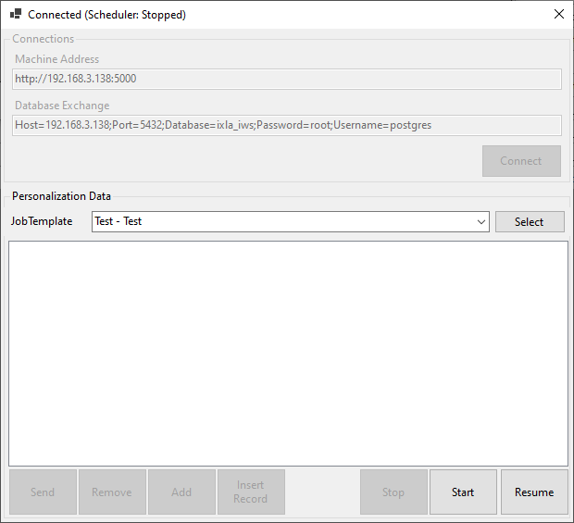

Provide a UI that let users:
- specify connection parameters to reach APIs and the PostgreSQL instance hosted by the machine.
- Select a job template from the list of configured templates on the machine
- Start the workflow scheduler
- Stop the workflow scheduler
- Resume the production process if it was put on hold because the input feeder was empty
- Insert data in data exchange tables. Clicking the “Add” button will open the “InsertDataForm”
The insert data form will just prepare data to be inserted in the data exchange table.
- Clicking the send button will effectively insert the prepared records in the data exchange table
- Clicking “Insert Record” will insert a record with mock data. It is there

InsertDataForm
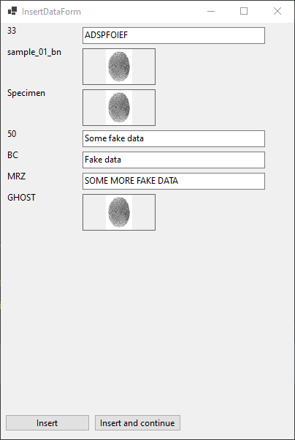

Presents a form with fields dynamically generated using information extracted from the job template. All this information can be retrieved via REST APIs.

JobStatusForm
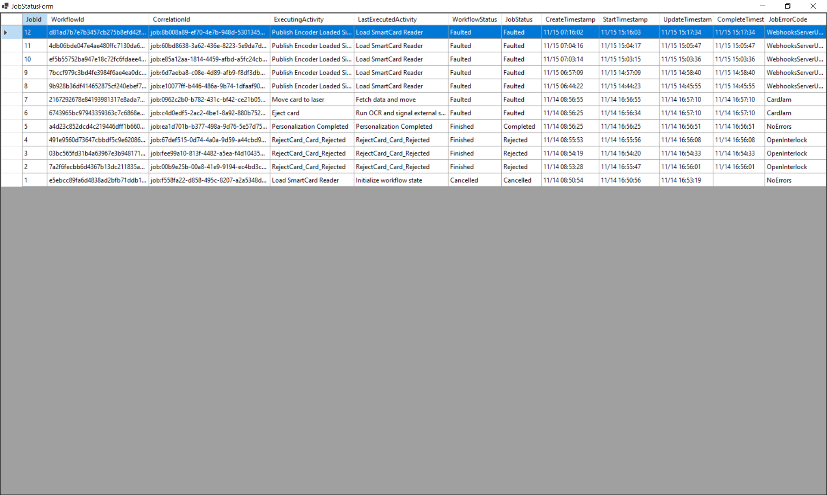

This is just a DataGridView that displays fields from the data exchange table that are managed by AIDA Server. It can be used to see the status of different personalization processes as they are executed by the machine.

Records that have JobStatus = “Suspended” can be “Resumed” or “Rejected” by right clicking the corresponding row and selecting the required action from a drop-down menu.

Source Code
Most of the code of the demo application is UI related stuff, you can find the important bits for the integration in 2 classes:

MachineInterface
This is just a facade that wraps a database connection and the SDK Client. It exposes methods that allow you to:

- Insert data in Data Exchange Tables
- Read data from Data Exchange Tables
- Fetch the list of available job templates
- Fetch the data exchange table field list and table name
- Start the workflow scheduler
- Stop the workflow scheduler
- Resume production after certain events (Feeder empty)
- Resume specific workflow instances

This class also retrieves the name of the generated data exchange table via API calls.

NotificationsController
It exposes a single endpoint where AIDA will send webhook messages. It deserializes the messages and puts then in a list. We are doing nothing with them at the moment.

The ConsoleDemo, is basically a webhooks receiver that “mocks” chip personalization. Instead of doing the real personalization, just pause them for a few seconds and the sends the completion message back to AIDA.

C# sample code

The provided sample application is developed using the functions of the IntegrationApi class and shows the sequence of calls to be made.
The application connects a device via its IP address, the Templates configured on the device are shown in the ComboBox at the top, after selecting a Template the parameters are shown in the central table and it is possible to change the default value of each single parameter, at this point you can decide to print a card or via the buttons at the bottom of the table transfer the record to the Orders table (bottom table) where it is possible to queue multiple items by creating a print queue, and print the cards in sequence.

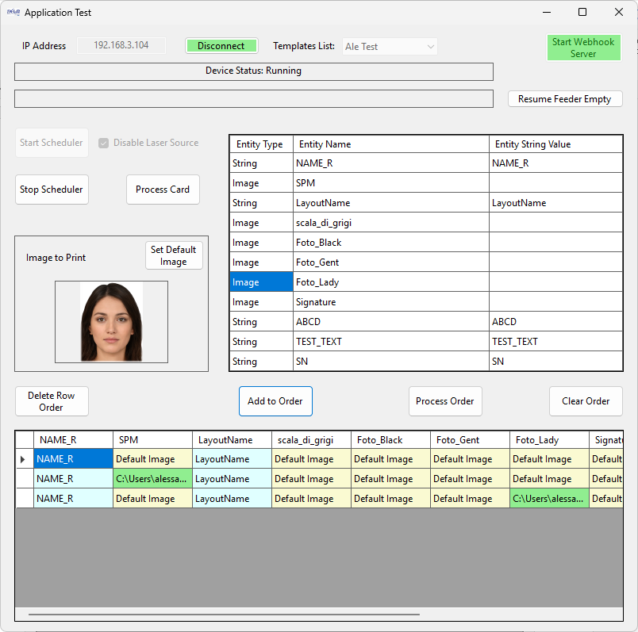
Below are all the main steps for making a card.

Connect
The first step is to configure the IP address of the IXLA device, turn on the device and, after the initial boot, read the IP of the device on the display, fill in the "IP address" field and press the "Connect" button.

Connect button
Sequence of APIs to call to connect the device:
- Create an instance of the IntegrationApi class passing the device URL as a parameter the port utilized is the 5000.
- Call the FindJobTemplates() function to get the list of templates configured on the device.
- Call the GetWorkflowSchedulerState() function to get the scheduler state
- Connecting the DB present in the device, the DeviceDB class, exports some methods that illustrate how to do it.

Sample code:
string ipAddress = tbIpAddress.Text;
baseUrl = $"http://{ipAddress}:5000";

// Connect the device
var api = new IntegrationApi(baseUrl);

// Get the list of the job templates present in the device
_templates = api.FindJobTemplates();

if (_templates.Total > 0)
{
int iiTemplate = 0;
// Add the work templates present in the device to the ComboBox
for (int i = 0; i < _templates.Total; i++)
comboTemplates.Items.Add(_templates.Items[i].Name);

….

// Check scheduler Status(api)
var state = api.GetWorkflowSchedulerState();
if (state.Status == WorkflowSchedulerStatus.Running)
{
for (iiTemplate = 0; iiTemplate < comboTemplates.Items.Count; iiTemplate++)
{
if (comboTemplates.Items[iiTemplate]?.ToString() == state.CurrentJobTemplateName)
break;
}
// If the template is already running ...
var template = api.GetJobTemplateById((int)state.CurrentJobTemplateId);
// ... and webhook is needed
if (template.WebhooksTarget != null)
{
btStartWebHook.BackColor = Color.LightGreen;
btStartWebHook.Enabled = false;
// ... restart the Webhook
btStartWebHook_Click(sender, e);
}

….
}
else
{
// There is no model configured in the device
comboTemplates.Text = "NO templates";
}
….

// Connecting to the device DB
if (_deviceDB == null)
{
_deviceDB = new DeviceDB(tbIpAddress.Text);
_deviceDB.Connect();
}
}

Start scheduler
Dopo aver collegato il dispositivo, è necessario avviare il servizio scheduler sul dispositivo; questo servizio interroga il DB in attesa che venga inserito un nuovo elemento nella tabella corrispondente al Template selezionato, con le informazioni necessarie per produrre una nuova scheda.
Before starting the scheduler, select a model to process in the “Model List” ComboBox, then press the “Start Process” button.

Sequence of APIs to call to start the scheduler:
- Create an instance of the IntegrationApi class passing the device URL as a parameter the port utilized is the 5000.
- Check the scheduler state for check is already running with the function api.GetWorkflowSchedulerState().
- Start the Webhook service if it is needed to complete some steps for card production.
- Set a structure WorkflowSchedulerStartupParamsDto and call the api.StartWorkflowScheduler() function that returns a WorkflowSchedulerStatusDto with the scheduler state.

Sample code:
var api = new IntegrationApi(baseUrl);
{
btStartProcess.Enabled = false;

var state = api.GetWorkflowSchedulerState();
if (state.Status == WorkflowSchedulerStatus.Running)
{
CheckStatus(api);
….
return;
}
var startupParams = new WorkflowSchedulerStartupParamsDto
{
// Template name to process
JobTemplateName = comboTemplates.Text,
// Obsolete
DisableRedPointer = false,
// Enable disable the laser source
DryRun = cbNoLaser.Checked,
// Execute or not a reset of the transport at the start of the scheduler
NoReset = false,
// Set to false, used for testing only
SkipEntityUpdates = false,
// Process a batch of n cards, -1 means all cards in the stacker
StopAfter = -1,
// Obsolete
TaskAllocationStrategy = null,
// Obsolete
WorkflowTypeName = @"AutoGeneratedWorkflow",
// Additional data
MetadataFields = new Dictionary<string, object> { ["machine_id"] = "00003" },
// Additional data returned with webhook callback
FilterJobsBy = new List<FilterDto>()
};
try
{
state = api.StartWorkflowScheduler(startupParams);
if (state.StopReason ==
WorkflowSchedulerStopReason.WebhooksServerUnreachabl
{
// Enable Webhook Server and retry start scheduler
btStartWebHook_Click(sender, e);
state = api.StartWorkflowScheduler(startupParams);
}

….
}
catch
{
state = api.GetWorkflowSchedulerState();
….
}

Stop scheduler
By calling the StopWorkflowSchedulerAsync() function is possible disable card production.

Sample code:
var api = new IntegrationApi(baseUrl);
{
await api.StopWorkflowSchedulerAsync(true);
CheckStatus(api);
}

Process Card
To print a card, simply fill in a row of the table in the DB corresponding to the selected Template. The table is composed of a column for each parameter configured in the template, plus a column plus some service columns such as job_status, job_error_code, session_id, correlation_id and batch_id. Correlation_id is a parameter left to the discretion of the user who can use it to correlate the element with the same element present in a user DB, while job_status must be filled in with the string "Waiting", the other columns will be filled in by the scheduler. It is not necessary to fill in all the columns, but only those different from the default values.
The table name corresponds to the selected Template and the Template-related parameters (called Entity) present in the table are returned by the scheduler via the GetDataExchangeTableDefinition() and GetEntityDescriptorsByJobTemplateId() functions.

Sequence of steps to execute to start printing a card:
- Create an instance of the IntegrationApi class passing the device URL as a parameter the port utilized is the 5000.
- Get the Entity list of the Template selected by the ID.
- Get the name of the table associated at the Template.
- Fill in the string with the data to customize the card and write them in the DB table associated with the Template, this is done through the DeviceDB class present in the sample.
- Check the result of the print operations.

Sample code:
private void btProcessCard_Click(object sender, EventArgs e)
{
int idxCombo = comboTemplates.SelectedIndex;

// Build the string for create the INSERT INTO DB command
_deviceDB.CreateNewCommand();
foreach (DataGridViewRow row in dgvEntity.Rows)
{
if ((row.Cells[(int)DgvColumns.StringToPrint].Value != null &&
row.Cells[(int)DgvColumns.StringToPrint].Value.ToString() != "") ||
row.Cells[(int)DgvColumns.PathImage].Value != null)
{
string? fieldName = row.Cells[(int)DgvColumns.UniqueName].Value.ToString();
_deviceDB.AddParameter(fieldName);
}
}

// Add job_status parameter
_deviceDB.AddParameter("job_status");
// Add optional correlation_id parameters
_deviceDB.AddParameter("correlation_id");

var api = new IntegrationApi(GetUrl());
{
var dbTable = api.GetDataExchangeTableDefinition((int)_templates.Items[idxCombo].Id);

// Compile the string to send at DB
_deviceDB.BuildCommand(dbTable.TableName);

foreach (DataGridViewRow row in dgvEntity.Rows)
{
if (row.Cells[(int)DgvColumns.StringToPrint].Value != null && row.Cells[(int)DgvColumns.StringToPrint].Value.ToString() != "")
{
_deviceDB.SetParameterString(row.Cells[(int)DgvColumns.UniqueName].Value.ToString(), row.Cells[(int)DgvColumns.StringToPrint].Value.ToString());
}

if (row.Cells[(int)DgvColumns.PathImage].Value != null)
{
_deviceDB.SetParameterImage(row.Cells[(int)DgvColumns.UniqueName].Value.ToString(), row.Cells[(int)DgvColumns.PathImage].Value.ToString());
}
}

_correlationId++;
var correlationId = $"job:{_correlationId:0000}";
// Set correlation_id and job_status parameter
_deviceDB.SetParameterString("correlation_Id", correlationId);
_deviceDB.SetParameterString("job_status", "Waiting");

// Execute the command (add item at DB)
_deviceDB.ExecuteCmd();
}
}

Webhook server Procedure
The Webhook server is called by the scheduler to notify the client application that a card has reached a predefined location and is waiting for an action from the user, or to notify the user application that production has been stopped because an alert such as feeder empty or open door has occurred.
The webhook server is a web server that opens port 7654 to receive messages; for convenience, an example of how it should be done and what messages it should process is provided in the ClientWebHost class that is part of the demo application but can reside in a separate application dedicated to handling received messages.
When the server receives a message, it should check whether it is a valid message and respond with OK() or BadRequest() if not, then process the message later.
This is the list of messages the server can receive:
- WorkflowSchedulerStoppedMessage
- WorkflowSchedulerStartedMessage
- WorkflowSchedulerProcessSuspendedMessage
- OcrReadBackMessage
- WorkflowCancelledMessage
- WorkflowCompletedMessage
- WorkflowFaultedMessage
- MagneticStripeReadBackMessage
- EncoderLoadedMessage
- OcrExecutedMessage

The example code illustrates message dispatch:
public async Task ProcessMessages(CancellationToken cancellationToken)
{
logger.LogInformation("Server started. Waiting messages...");
while (!cancellationToken.IsCancellationRequested)
{
Try
{
var aidaMessage = messages.TakeMessage();
if (aidaMessage is null)
{
await Task.Delay(250, default);
continue;
}

var eventMessage = aidaMessage.Message;
if (eventMessage.JobId is null)
{
if (eventMessage.MessageType != MessageType.HealthCheck)
logger.LogInformation("Message {MessageType}",eventMessage.MessageType);
}

if (eventMessage.JobId is not null)
logger.LogInformation("CorrelationId: {CorrelationId} job id: {JobId}, event:{WorkflowEvent} status: {Status}, error code: {ErrorCode}, document produced: {DocumentProduced}",
eventMessage.CorrelationId,
eventMessage.JobId,
eventMessage.MessageType,
eventMessage.JobStatus,
eventMessage.ErrorCode,
eventMessage.DocumentProduced);

var ipAddress = aidaMessage.IpAddress;
var client = clientFactory(ipAddress);

switch (eventMessage)
{
case WorkflowSchedulerStoppedMessage stopped:
logger.LogWarning("Workflow Scheduler stopped. Error code = {ErrorCode}, stop reason = {StopReason}, source job id = {SourceJobId}",
stopped.ErrorCode,
stopped.StopReason,
stopped.SourceJobInstanceId);
break;

case WorkflowSchedulerStartedMessage:
logger.LogInformation("Workflow Scheduler started");
break;

// These are notifications that indicate that the workflow was suspended
// The workflow was suspended because AIDA was not able to get the
// card from the feeder or it was about to move a card in the engraving
// position but open interlocks where found.
case WorkflowSchedulerProcessSuspendedMessage suspended:
switch (suspended.ErrorCode)
{
case JobErrorCodes.CardJam: break;

case JobErrorCodes.FeederEmpty:
// Intentionally block until we receive user input
logger.LogWarning("\n\nFeeder empty\nLoad the input feeder with cards and press the 'Resume' button");
break;
case JobErrorCodes.OpenInterlock:
logger.LogWarning("\n\n Open interlocks detected. Please verify all interlocks are properly locked, then click the 'Resume'");
break;
}
break;

case OcrReadBackMessage readBackMessage:
logger.LogInformation("CorrelationId: {CorrelationId}, JobId: {JobId}, Confidence: {Confidence}, Text: \n'{Text}'", readBackMessage.CorrelationId,
readBackMessage.JobId,
readBackMessage.Text, readBackMessage.MeanConfidence);
_ = MockOcrReadBackValidation(readBackMessage, client);
break;

// These are fire and forget for AIDA.
case WorkflowCancelledMessage: break;
case WorkflowCompletedMessage: break;
case WorkflowFaultedMessage: break;

case MagneticStripeReadBackMessage readBack:
logger.LogInformation("MAGNETIC READ_BACK RECEIVED");
_ = MockMagneticReadBackValidation(readBack, client);
break;

// These events require the receiving application
// to invoke SignalExternalProcessCompleted.
// The card is positioned in the SmartCard reader. AIDA is waiting
// the external application to signal the completion (and outcome)
// of the operation.
case EncoderLoadedMessage encoderLoaded:
// Mock the chip personalization process.
_ = MockChipEncodingPersonalization(encoderLoaded, client, CancellationToken.None).ConfigureAwait(false);
break;

// AIDA executed an OCR operation successfully. The notification
// contains the list of results obtained from the OCR reading,
// it now expects the receiving application to validate the
// results and signal the outcome of the validation
case OcrExecutedMessage ocrMessage:
_ = MockOcrValidation(ocrMessage, client, CancellationToken.None).ConfigureAwait(false);
break;
}
}
catch (Exception e)
{
logger.LogError(e, "Failed to process AIDA notification");
}
}
}

Integration API list

API Integration list:
- FindJobTemplates()
Returns a SearchJobTemplatesResultDto class, that contains a list of JobTemplateDto
class one for each template configured on the device.
Class SearchJobTemplatesResultDto
{
List<JobTemplateDto> items;
int page;
int pageSize;
int total;
}

- GetWorkflowSchedulerStateAsync()
Returns a WorkflowSchedulerStateDto class that contains the scheduler state of the device.
Class WorkflowSchedulerStateDto
{
enum WorkflowSchedulerStatus status;
enum WorkflowSchedulerStopReason stopReason;
enum WorkflowSchedulerErrorCodes errors;
string stopSourceJobId;
int queueSize;
List<int> queueOrderIds;
string errorDetails;
int lastLoadedItemId;
int upTimeSeconds;
string currentJobTemplateName;
string workflowTypeName;
string sessionId;
}

- StartWorkflowSchedulerAsync()
Activates the job scheduler with the parameters passed in the WorkflowShedulerStartupParamsDto structure.
This function returns a WorkflowSchedulerStateDto structure with the response whether the job has been started.
Class WorkflowShedulerStartupParamsDto
{
float rejectedCardsThreshold;
string workflowTypeName; // Deprecated
string jobTemplateName;
int stopAfter;
bool dryRun;
string taskAllocationStrategy; ???
bool noReset;
bool disableRedPointer;
bool skipEntityUpdates; ???
Dictionary<string, Object> metadataFields; ???
List<FilterDto> FilterJobsBy ???
}

- StopWorkflowSchedulerAsync()
Stop the job process scheduler, return a WorkflowSchedulerStateDto structure with the response.

- GetEntityDescriptorsByJobTemplateIdAsync()
Returns a list of EntityDescriptor classes associated with the model.
Class EntityDescriptor
{
int entityIndex;
string entityName;
string groupName;
string displayName;
string dbValueType;
string pageName;
bool isConstant;
}

- GetJobTemplateByIdAsync()
Returns a JobTemplateDto class, populated with data from the active job template.
Class JobTemplateDto
{
int id;
string name;
string description;
DateTime createdAt;
DateTime updatedAt;
string expectedMarkDuration;
class DRectangleDto workingArea
class ReadBackConfigurationDto readBackConfiguration
class ChipEncodingConfigurationDto chipEncodingConfiguration
class MagneticStripeConfigurationDto magStripeConfiguration
class WebhooksTargetDto webhooksTarget
class FileDto file;
class DataSourceConfigurationDto dataSourceConfiguration
List<JobTemplateLayoutDto> layouts
List<JobTemplateInkjetLayoutDto> inkjetLayouts
ListScannerMarkGroupDto> markGroups
List<JobTemplateOcrSettingsDto> ocrSettings
bool autoPosEnabled;
}

- Funzioni per aggiungere i dati nel DB.

- GetDataExchangeTableDefinitionAsync()
Returns a DataExchangeTableDefinition class, populated with the reference to the DB table associated with the job model.
Class GetDataExchangeTableDefinitionAsync
{
string sql;
string tableName;
}

Structures and Enum

Class JobTemplateDto
{
int id;
string name;
string description;
DateTime createdAt;
DateTime updatedAt;
string expectedMarkDuration;
class DRectangleDto workingArea;
class ReadBackConfigurationDto readBackConfiguration;
class ChipEncodingConfigurationDto chipEncodingConfiguration;
class MagneticStripeConfigurationDto magStripeConfiguration;
class WebhooksTargetDto webhooksTarget;
class FileDto file;
class DataSourceConfigurationDto dataSourceConfiguration;
List<JobTemplateLayoutDto> layouts;
List<JobTemplateInkjetLayoutDto> inkjetLayouts;
List<ScannerMarkGroupDto> markGroups;
List<JobTemplateOcrSettingsDto> ocrSettings;
bool autoPosEnabled;
}

class DRectangleDto
{
double x;
double y;
double width;
double height;
string datatype;
}

class ReadBackConfigurationDto
{
enum ReadBackType ReadBackType;
enum SupportSide requiredSide;
string discriminator;
int id;
string name;
int jobTemplateId;
}

class ChipEncodingConfigurationDto
{
enum ReaderAccessType readerAccessType;
enum ReaderInterfaceType readerInterfaceType;
int id;
}

class MagneticStripeConfigurationDto
{
enum MagneticStripeOperations operations;
int id;
bool highCoercivity;
bool track1Enabled;
bool track2Enabled;
bool track3Enabled;
}

class WebhooksTargetDto
{
int id;
string name;
string baseUri;
DateTime createdAt;
DateTime updatedAt;
}

class FileDto
{
string filename;
string originalFilename;
string displayName;
long size;
string location;
string checksum;
string extension;
DateTime createdAt;
DateTime updatedAt;
}

class DataSourceConfigurationDto
{
DataSourceType dataSourceType;
string discriminator;
int id;
string name;
bool canBeDeleted;
}

class JobTemplateLayoutDto
{
int id;
string name;
int index;
int layoutId;
int jobTemplateId;
string supportSide;
bool mirrorX;
bool mirrorY;
List<JobTemplateLayoutAutoPosSettingsDto> autoPosSettings;
}

class JobTemplateLayoutAutoPosSettingsDto
{
int id;
int index;
int layoutId;
int jobTemplateId;
string layoutName;
string displayName;
float threshold;
string debugUrl;
class TemplateMatchingConfigurationDto templateMatchingConfiguration;
bool isConfigured;
}

class TemplateMatchingConfigurationDto
{
int id;
string name;
string displayName;
string description;
double threshold;
bool warpPerspective;
string scannerId;
string cameraId;
string acquisitionPresetName;
DateTime createdAt;
DateTime updatedAt;
class RectangleDto searchArea;
class RectangleDto templateArea;
class ApplicationImageDto searchPatternImage;
bool isConfigured;
string debugUrl;
class ScannerModuleDefinition scannerModule;
}
class RectangleDto
{
int x;
int y;
int width;
int height;
string datatype;
}

class ApplicationImageDto
{
int id;
class FileDto file;
int fileId;
int height;
int width;
float horizontalResolution;
float verticalResolution;
string imageFormat;
string url;
}

class ScannerModuleDefinition
{
int id;
string baseAddress;
string name;
string displayName;
string positionId;
List<DeviceDefinition> devices;
string deviceId;
}

Class DeviceDefinition
{
string id;
string name;
string model;
string displayName;
string positionId;
string description;
string serialNumber;
string moduleId;
}

class JobTemplateInkjetLayoutDto
{
int id;
class InkjetLayoutDto layout;
int index;
int layoutId;
int jobTemplateId;
string supportSide;
class PrintSettingsDto printSettings;
}

class PrintSettingsDto
{
int jobTemplateInkjetLayoutId;
int id;
bool verticalMirrorEnabled;
bool horizontalMirrorEnabled;
bool cmykDirectEnabled;
bool enableC;
bool enableM;
bool enableY;
bool enableK;
int dropSize;
bool multipass;
int numberOfPasses;
int dataPageId;
}

class InkjetLayoutDto
{
int id;
Datetime createdAt;
DateTime updatedAt;
string name;
List<InkjetEntityDto> entities;
bool canBeDeleted;
}

class InkjetEntityDto
{
int id;
string name;
string displayName;
float x;
float y;
int width;
int height;
}

class ScannerMarkGroupDto
{
int id;
string name;
string displayName;
string description;
string scannerId;
string positionId;
string supportSide;
string deviceId;
int index;
int jobTemplateId;
List<MarkGroupScannerEntityDto> entities;
string expectedMarkDuration;
}

class MarkGroupScannerEntityDto
{
int index;
int entityId;
int markGroupId;
string deviceId;
string positionId;
string supportSide;
class ScannerEntityDto entity;
}

class ScannerEntityDto
{
enum EntityType type;
int id;
int penId;
int markLoopCount;
class ScannerEntityMarkFlagsDto markFlags;
string name;
string displayName;
string prefix;
int userData;
int layoutId;
string layoutName;
double rotationAngle;
string expectedMarkDuration;
class DRectangleDto Outline;
string text;
string fontName;
double textSize;
double textOrientation;
double charSpacing;
double textBaseline;
double textHeightLimit;
double textLengthLimit;
double textRadius;
double textStartAngle;
class ScannerEntityBitmapModeFlags itmapModeFlags;
double imageIntensity;
double imageBrightness;
double imageDitherStep;
List<HatchPairDto> hatchPairs;
}

class ScannerEntityMarkFlagsDto
{
bool markContour;
bool markHatch;
}

class ScannerEntityBitmapModeFlags
{
bool invert;
bool grayscale;
bool drillMode;
bool drillGrayscale;
bool bidirectional;
bool startLastLine;
bool noLineIncrement;
bool showBitmap;
bool scanXDir;
bool penFrequency;
bool jumpOverBlankPixel;
}

class HatchPairDto
{
int index;
string name;
class HatchSettingsDto hatch1;
class HatchSettingsDto hatch2;
}

class HatchSettingsDto
{
enum HatchFlags flags;
enum HatchStyle hatchStyl;
string name;
double hatchDistance;
double hatchAngle;
double beamCompensation;
bool enabled;
}

class JobTemplateOcrSettingsDto
{
int id;
int jobTemplateId;
int ocrSettingsId;
string name;
bool runBeforeMark;
string resultFieldName;
bool sendWebhookNotification;
class OcrSettingsDto ocrSettings;
}

class OcrSettingsDto
{
int id;
string name;
class RectangleDto roi;
DataTime createdAt;
DataTime updatedAt;
string whiteList;
string blackList;
string languages;
int multiply;
int threshold;
double rotation;
string matchPattern;
double meanConfidenceThreshold;
string imageAcquisitionPreset;
string scannerId;
string cameraId;
bool canBeDeleted;
}

class FilterDto
{
string fieldName;
List<string> value;
}

